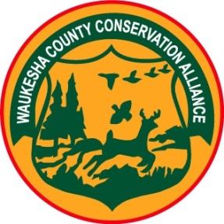 Waukesha County Conservation Alliance

N142W8286 Merrimac Drive

Menomonee Falls, WI 53051

waukeshacountyconservationalliance.com

**Waukesha County**

**Conservation Alliance**

**---------------------------------------------------------------------------------------------**

***Dedicated to Succeeding Generations***

**Board Meeting: MAY 18, 2022**

Al Shook called the meeting to order at 7:15pm

In attendance: Al Shook, Ron Gray, Randy Farchmin, MarySusan Diedrich, Jeff Hintz

Bob Wincek, Jean Tackes

**Grant Requests**

Schultz Rod & Gun requesting $400 to offset costs associated with “Take Aim at Cancer” Shoot on

9-10-22. Wincek made a motion to recommend to the Membership to grant the request. Second by Gray. Unanimous approval.

Lac LaBelle requesting $10,000 for a $30,000 project building a carp barrier for Lac LaBelle. Since the request City of Oconomowoc and the WI DNR have given approval for the project. Installation to be announced. Hintz made a motion to recommend to the Membership to offer $2,500.00. Discussion followed: WCCA recently donated $2,000.00 for a kayak launch on Lac LaBelle. Although this barrier will help keep the carp out, there are already carp in the lake. At this time, we know of no one else that has been asked for or agreed to donations. Diedrich suggested we change this to a $1,000.oo donation. We could give a matching fund grant for a specific amount. Wincek made a friendly amendment to Hintz’s motion, Hintz agreed, to change the amount to $1,000.00. Unanimously approved.

**Other Business**

**None**

**Adjournment**

Al Shook adjourned the meeting at 731 pm.

Respectfully submitted,

MarySusan Diedrich

WCCA Secretary